**Bloggle Clone Project**

|  |  |
| --- | --- |
| **Timeline** | **Budget** |
| 2 Months | 130,000/- |

**User Dashboard**

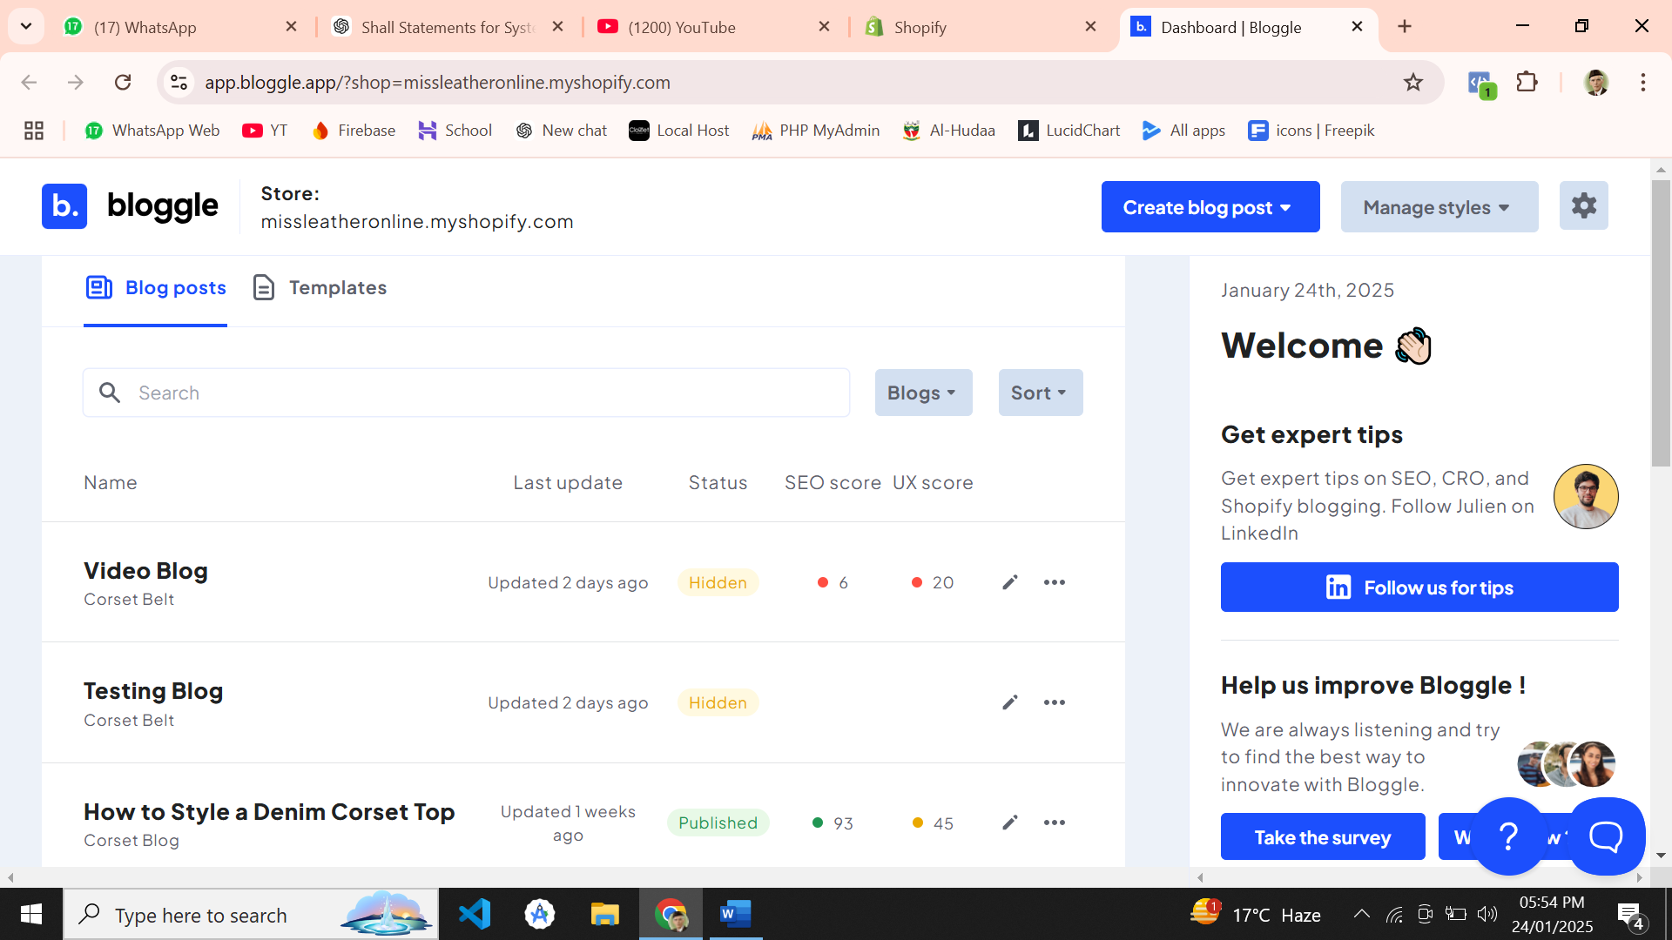

Our dashboard will have an additional section named as statistics; Statistics section will not develop in initial phase but we will develop at the end of the project.

**My Templates Option**

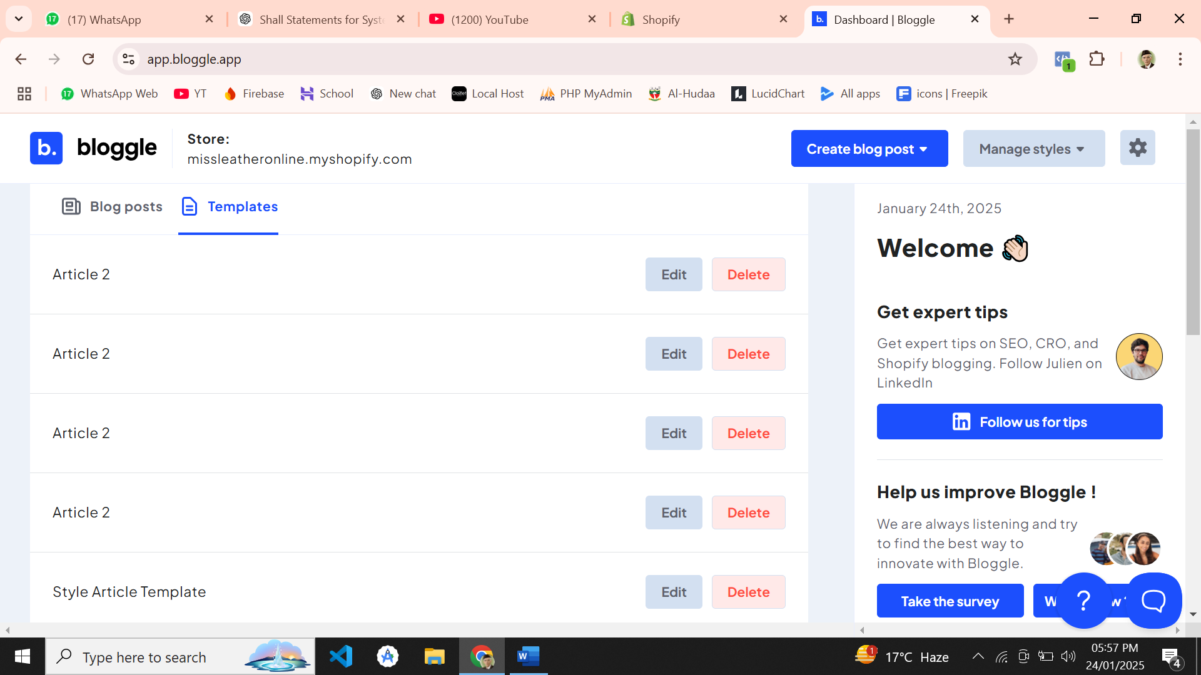

**Blog Editor**

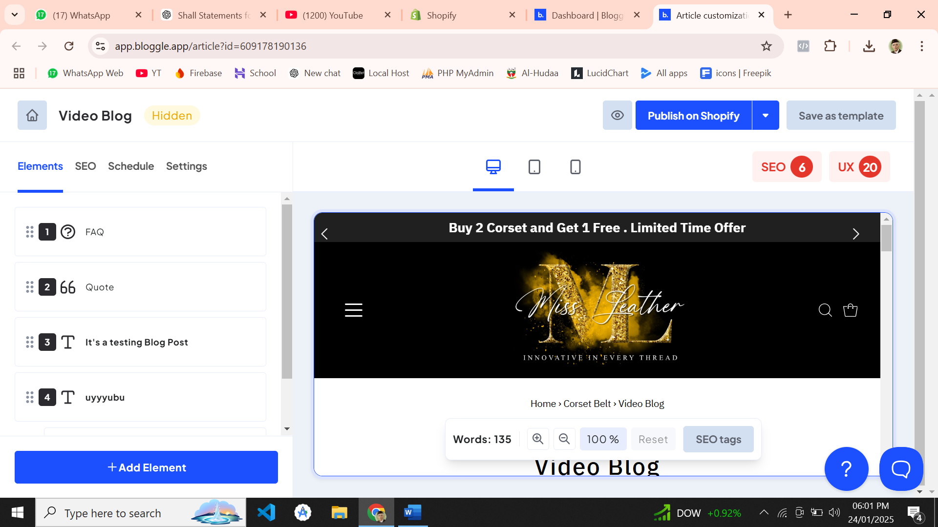

Blog editor will have all the features of bloggle, but with some extra customization option in elements which may possible.

Below I’ll list all the elements which we will add.

**Content**

* Heading
* Paragraph
* Table of contents
* Author
* Summary
* FAQ
* Quote
* Two Text Columns

**Products**

* One Product
* Products Gallery
* Popular
* Product + Text
* Product Grid

**Medias**

* Image
* Images Gallery
* Two Images Columns
* Three Images Columns
* Text + Image
* Video
* Text + Video

**Other**

* Button
* Divider
* Embed Code
* Klaviyo Form
* Related Blogs
* Social Share
* Recipe Header

**Create My Style**

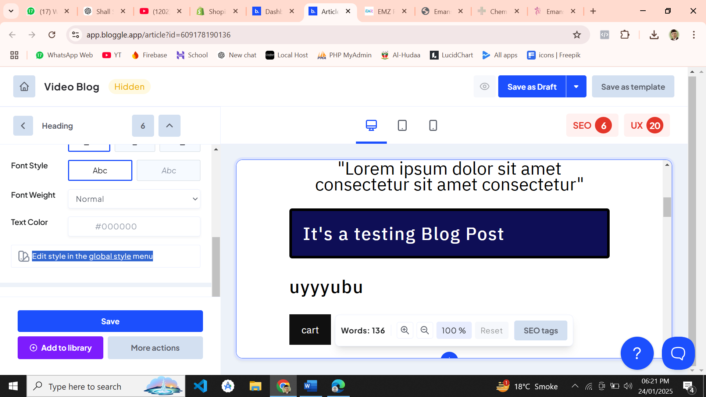

Edit style in *global menu*. After clicking we’ll redirect user to new Page.

**Global Style Menu**

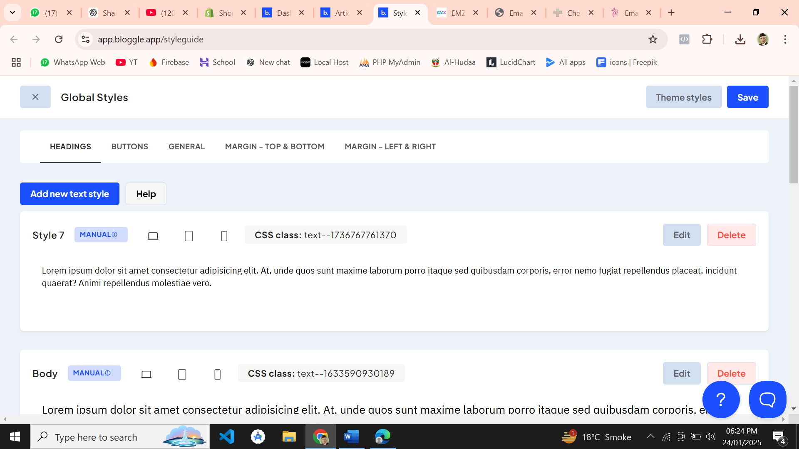

In this section user can create their styles for global use.